Living Hope Church
An Evangelical Free Church

Joy in Family
Luke 1:26-38
December 1, 2024

Pastor Andrew Johnson

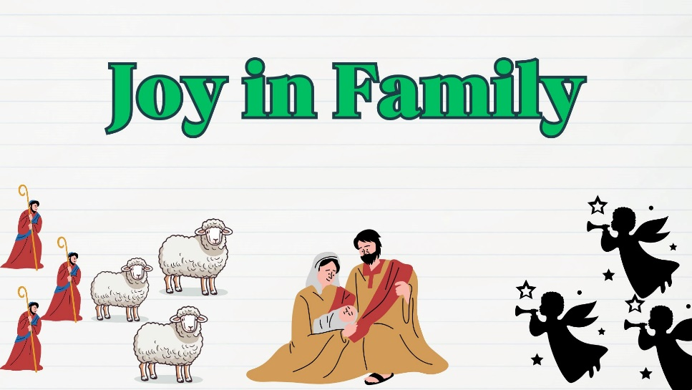

Living Hope for All Generations

Sunday Worship 10:30 am
KNZZ broadcast 9:30 am
www.livinghopefree.church
2840 B ½ Road – (970) 243-0402
wifi password: livinghope
Living Hope Church
An Evangelical Free Church

Joy in Family
Luke 1:26-38
December 1, 2024

Pastor Andrew Johnson

Living Hope for All Generations

Sunday Worship 10:30 am
KNZZ broadcast 9:30 am
www.livinghopefree.church
2840 B ½ Road – (970) 243-0402
wifi password: livinghope
Counters: Bill Brown, Matthew Johnson

This week we are praying for:
Michael and Arielle Hewitt, CRU in Germany – Pray for the workshops they are leading and their work in Missionary happiness.

Volunteering – Let us know if you can volunteer to count the offering, greet or teach children’s church.

Missionary Updates– An update is available from Carolyn Pinkley.

Pot Luck– Join us after church next week, December 8th for our Pot Luck! Sign up now to bring a dish.

Youth Events– We are having events for people in middle school and up, come join us at 5pm on Sundays! (Not this week)

 | October | Year-to-date
Income | $9,983 | $90,564
Expenses | $9,930 | $90,516
Difference | $53 | $48
Heavenly Father: Please draw __________________ to Jesus
and make him/her an ambassador of Christ.

Sermon Notes

Living Hope Church Grand Junction Colorado
Counters: Bill Brown, Matthew Johnson

This week we are praying for:
Michael and Arielle Hewitt, CRU in Germany – Pray for the workshops they are leading and their work in Missionary happiness.

Volunteering – Let us know if you can volunteer to count the offering, greet or teach children’s church.

Missionary Updates– An update is available from Carolyn Pinkley.

Pot Luck– Join us after church next week, December 8th for our Pot Luck! Sign up now to bring a dish.

Youth Events– We are having events for people in middle school and up, come join us at 5pm on Sundays! (Not this week)

 | October | Year-to-date
Income | $9,983 | $90,564
Expenses | $9,930 | $90,516
Difference | $53 | $48
Heavenly Father: Please draw __________________ to Jesus
and make him/her an ambassador of Christ.

Sermon Notes

Living Hope Church Grand Junction Colorado

