Living Hope Church
An Evangelical Free Church

Three Kings
Matthew 3
December 22, 2024

Pastor Andrew Johnson

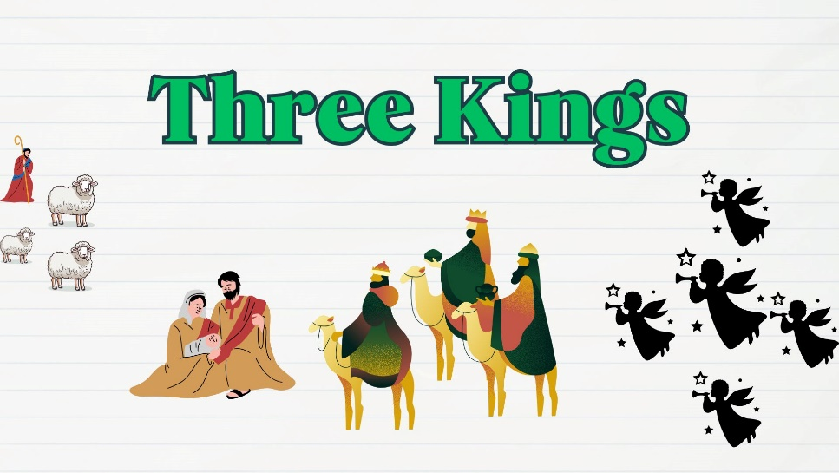

Living Hope for All Generations

Sunday Worship 10:30 am
KNZZ broadcast 9:30 am
www.livinghopefree.church
2840 B ½ Road – (970) 243-0402
wifi password: livinghope
Living Hope Church
An Evangelical Free Church

Three Kings
Matthew 3
December 22, 2024

Pastor Andrew Johnson

Living Hope for All Generations

Sunday Worship 10:30 am
KNZZ broadcast 9:30 am
www.livinghopefree.church
2840 B ½ Road – (970) 243-0402
wifi password: livinghope
Greeter: Jerry Pike, Counters: Stephen Johnson, Matthew Johnson

This week we are praying for:
Matthew Johnson – InterVarsity CMU – Pray for the winter break to be a restful time, for the students to be impassioned for Christ, and to return to CMU with increased desire for God.

Volunteering – Let us know if you can volunteer to count the offering, greet or teach children’s church.

Christmas Eve Service– Join us on Christmas Eve at 6:30pm to celebrate the birth of the one true king!

Congregational Meeting– Join us for our bi-annual meeting on January 26th after the service.

Youth Events– We are having events for people in middle school and up, come join us at 5pm on Sundays!

 | November | Year-to-date
Income | $4,415 | $94,979
Expenses | $8,807 | $99,323
Difference | $-4,392 | $-4,344
Heavenly Father: Please draw __________________ to Jesus
and make him/her an ambassador of Christ.

Sermon Notes

Living Hope Church Grand Junction Colorado
Greeter: Jerry Pike, Counters: Stephen Johnson, Matthew Johnson

This week we are praying for:
Matthew Johnson – InterVarsity CMU – Pray for the winter break to be a restful time, for the students to be impassioned for Christ, and to return to CMU with increased desire for God.

Volunteering – Let us know if you can volunteer to count the offering, greet or teach children’s church.

Christmas Eve Service– Join us on Christmas Eve at 6:30pm to celebrate the birth of the one true king!

Congregational Meeting– Join us for our bi-annual meeting on January 26th after the service.

Youth Events– We are having events for people in middle school and up, come join us at 5pm on Sundays! (Not this week)

 | November | Year-to-date
Income | $4,415 | $94,979
Expenses | $8,807 | $99,323
Difference | $-4,392 | $-4,344
Heavenly Father: Please draw __________________ to Jesus
and make him/her an ambassador of Christ.

Sermon Notes

Living Hope Church Grand Junction Colorado

