Living Hope Church
An Evangelical Free Church

Obedience and Sacrifice
Haggai
October 27, 2024

Pastor Andrew Johnson

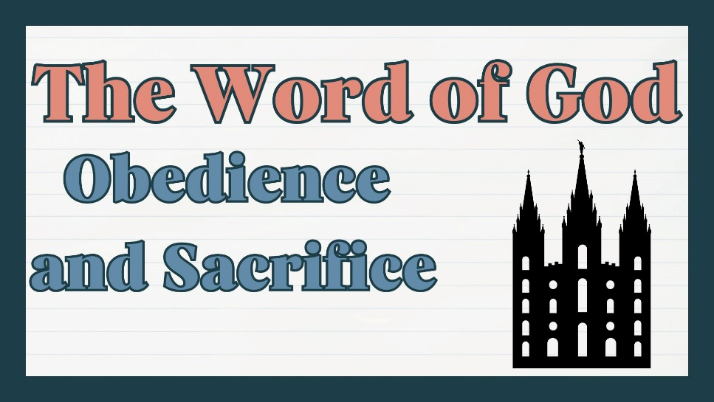

Living Hope for All Generations

Sunday Worship 10:30 am
KNZZ broadcast 9:30 am
www.livinghopefree.church
2840 B ½ Road – (970) 243-0402
wifi password: livinghope
Living Hope Church
An Evangelical Free Church

Obedience and Sacrifice
Haggai
October 27, 2024

Pastor Andrew Johnson

Living Hope for All Generations

Sunday Worship 10:30 am
KNZZ broadcast 9:30 am
www.livinghopefree.church
2840 B ½ Road – (970) 243-0402
wifi password: livinghope
Counters: Matthew Johnson, Stephen Johnson

This week we are praying for:
Barry Vegter – Rocky Mountain District EFC – Pray for revival in the district, and an increased sense of mission.

Volunteering – Let us know if you can volunteer to count the offering, greet or teach children’s church.

Youth Events– We are having events for people in middle school and up, come join us! Apple Fest – October 27th Pumpkin Smash – November 3rd

Operation Christmas Child– If you are interested in Operation Christmas Child, please pick up a box in the foyer. These boxes will be filled and sent out around the world along with local language gospel presentations.

 | September | Year-to-date
Income | $7,666 | $80,581
Expenses | $7,487 | $80,586
Difference | $179 | -$6
Heavenly Father: Please draw __________________ to Jesus
and make him/her an ambassador of Christ.

Sermon Notes

Living Hope Church Grand Junction Colorado
Counters: Matthew Johnson, Stephen Johnson

This week we are praying for:
Barry Vegter – Rocky Mountain District EFC – Pray for revival in the district, and an increased sense of mission.

Volunteering – Let us know if you can volunteer to count the offering, greet or teach children’s church.

Youth Events– We are having events for people in middle school and up, come join us! Apple Fest – October 27th Pumpkin Smash – November 3rd

Operation Christmas Child– If you are interested in Operation Christmas Child, please pick up a box in the foyer. These boxes will be filled and sent out around the world along with local language gospel presentations.

 | September | Year-to-date
Income | $7,666 | $80,581
Expenses | $7,487 | $80,586
Difference | $179 | -$6
Heavenly Father: Please draw __________________ to Jesus
and make him/her an ambassador of Christ.

Sermon Notes

Living Hope Church Grand Junction Colorado

