Living Hope Church
An Evangelical Free Church

God’s Word in Hard Times
Jeremiah
October 13, 2024

Pastor Andrew Johnson

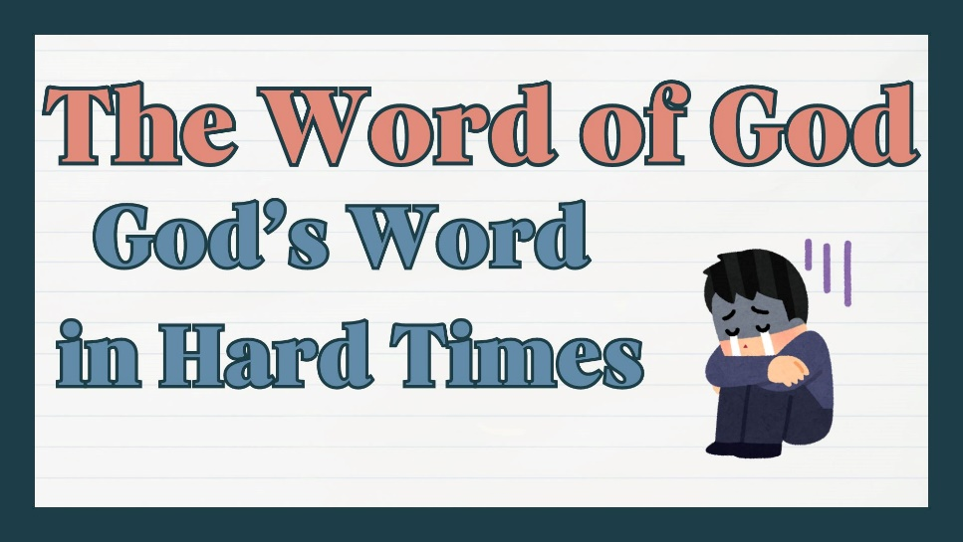

Living Hope for All Generations

Sunday Worship 10:30 am
KNZZ broadcast 9:30 am
www.livinghopefree.church
2840 B ½ Road – (970) 243-0402
wifi password: livinghope
Living Hope Church
An Evangelical Free Church

God’s Word in Hard Times
Jeremiah
October 13, 2024

Pastor Andrew Johnson

Living Hope for All Generations

Sunday Worship 10:30 am
KNZZ broadcast 9:30 am
www.livinghopefree.church
2840 B ½ Road – (970) 243-0402
wifi password: livinghope
Counters: Matthew Johnson, Stephen Johnson

This week we are praying for:
Lydia Sears – InterVarsity Christian Fellowship CMU – Pray for their new baby, Walt, for peace and patience in a time of rest.

Volunteering – Let us know if you can volunteer to count the offering, greet or teach children’s church.

Youth Events– We are having events for people in middle school and up, come join us! Nerf War – October 13th Apple Fest – October 20th

Operation Christmas Child– If you are interested in Operation Christmas Child, please pick up a box in the foyer. These boxes will be filled and sent out around the world along with local language gospel presentations.

Trunk Or Treat and Worship – October 26th, 1 to 3pm, with live music! Decorate your car and come to give out candy to kids in the neighborhood. Or just join us for worship in front of the church. If you are able to donate candy for the event, you can drop it by the office.

 | September | Year-to-date
Income | $7,666 | $80,581
Expenses | $7,487 | $80,586
Difference | $179 | -$6
Heavenly Father: Please draw __________________ to Jesus
and make him/her an ambassador of Christ.

Sermon Notes

Living Hope Church Grand Junction Colorado

Counters: Matthew Johnson, Stephen Johnson

This week we are praying for:
Lydia Sears – InterVarsity Christian Fellowship CMU – Pray for their new baby, Walt, for peace and patience in a time of rest.

Volunteering – Let us know if you can volunteer to count the offering, greet or teach children’s church.

Youth Events– We are having events for people in middle school and up, come join us! Nerf War – October 13th Apple Fest – October 20th

Operation Christmas Child– If you are interested in Operation Christmas Child, please pick up a box in the foyer. These boxes will be filled and sent out around the world along with local language gospel presentations.

Trunk Or Treat and Worship – October 26th, 1 to 3pm, with live music! Decorate your car and come to give out candy to kids in the neighborhood. Or just join us for worship in front of the church. If you are able to donate candy for the event, you can drop it by the office.

 | September | Year-to-date
Income | $7,666 | $72,915
Expenses | $7,487 | $73,100
Difference | $179 | -$6
Heavenly Father: Please draw __________________ to Jesus
and make him/her an ambassador of Christ.

Sermon Notes

Living Hope Church Grand Junction Colorado

